Line Follower Simulator (LFS)
by Ron Grant

Sample Tricycle Controller
by Will Kuhnle

USER'S GUIDE Sep 26, 2020

PROPOSED SIMULATOR FOR DPRG

vChallenge Line Following Contest 2020

Replaces pre-Library version of program User's Guide Aug 11

The library code and bundled demo sketches are included on Git Hub at
https://github.com/ron-grant/LFS
Table of Contents
Introduction 3
LFS Environment - Processing (Java based IDE) 4
Few Notes On Java, If You Have C, C++ Background 5
System Requirements 5
Simulation Loop 6
Sensors 7
Getting Started With LFS 7
Key Command Summary 8
Mouse Commands 8
Example Controllers Included 9
Writing A Controller 10
Description Of LFS Files (IDE Notebook Tabs) 11
LFS World Coordinates 12
Robot Heading 13
Robot Coordinates / Robot View 14

Introduction

LFS is a Processing library that provides a framework for developing a line following robot controller through real-time simulation.

An image of a line following course is used as the simulated robots world which is imaged with a down looking camera attached to the robot.

Robot camera images are not obscured by the robot allowing for placement of user sensors without any constraints. Of course sensor placement might need to be a consideration when if developing a real world robot.

The first model developed for LFS is that of a differential drive robot, e.g. , a two wheeled robot with caster. This model accepts target turn rate and forward speed as inputs to move the robot around in the world which is a 2D surface defined by the course image.

Will Kuhnle's included tricycle robot sketch is a variation that uses a steering wheel angle and wheel steering “speed” to move his simulated robot.

Currently DPRG line following courses use (for the most part) a 12 inch square tile as a common size to contain a course feature, e.g. line segment, 90 degree turn, etc.

LFS is informed of the course scale in “dots per inch” (DPI). A suggested scale is 64 DPI. At this scale a each 12” x 12” tile is 768 pixels. The current Challenge course including 6” borders is 7x13 tiles or 5376x9984 pixels. This is a very large bit map.

Sample course images are provided including advanced level features. Also, an image of the DPRG Challenge course is provided, bundled with example sketches in their data sub-folder.

Depending on the sensor view size (default 800x800 pixels), the area imaged by the simulators camera is about 1 square foot (12.5” x 12.5”) where the center of the robot (midpoint between the drive wheels) is placed at the center of the robot viewport. Sensors including spot and line sensors can be defined which sample the screen image and report their data to the controller program which you write.

Note: Other image processing techniques could be applied to the “camera” image. Processing is capable of specifying a 3D perspective camera if you are interested in simulating a video camera, but for this implementation I avoided adding in this complexity.

LFS presents sensor data at a fixed stepTime (default value 1/60th second) to the user's controller program (java method) which must provide turn rate and forward velocity values which are used by the simulator to update robots position and heading.

It is important to note this simulation step time is independent of realtime. The simulation can be frozen or step as slow as about 1 step per second. Also, if CPU & GPU are fast enough faster than realtime simulation is quite helpful.

Again, the results of the simulation are the same regardless of how fast it is able or allowed to run. Program code runs on the CPU on a single thread. Most of the image display portions are run using graphics processing unit (GPU) on board your video/graphics card.

LFS provides simple keyboard and mouse interface, single key commands and ability look at an overhead view of entire course showing cookie crumb trail of robots path.

Also, the robot can be driven manually by keyboard commands or by user controller which can be enabled / disabled by key command.

The robot can also be interactively positioned and its heading adjusted.

LFS Environment - Processing (Java based IDE)

LFS uses the Processing programming environment which is available for free (or donation!) at processing.org.

Processing is Java based, but only a basic understanding of java is needed for a user to write a controller of reasonable complexity. The Arduino IDE is modeled after the Processing IDE, so if you have a little experience with Arduino, the Processing environment should present no difficulty.

A processing sketch (program) is composed of methods (similar to C functions) you write including a setup() method that is called one time then draw() which is called at video frame rate, e.g. typically at 60 times per second. In the case of LFS, a core sketch program is provided where you (the user) will write a few key methods, relevent to your controller, which can be derived from example sketches bundled with the LFS library.

The example sketches separate different logical groups of program code into separate notebook tabs. Each tab is stored in a separate (.pde) file, which are combined into a single file at run (compile and run) time by Processing. Also, you can add more program tabs if you need them to help organize your program.

For very complex programs, beyond say your line follower controller, other options exist when using processing, for example you can create pure Java code that is independent of processing or can write classes that are passed a reference to the class called PApplet which all your normal processing code including classes you may write exist. Other programming environments such as Eclipse can be used to create Java programs that are able to use the processing run time functionality (importing processing.core library) and also then in this case import the LFS library, LineFollowerSim.

Processing Help allows easy access to information about the Language including their Reference page (https://processing.org/reference/) which is quite handy.

The included debugger can be quite helpful allowing you to set break points and monitor variables.

Tweak mode allows adjusting program constant values defined typically in methods that are called repetitively (not global constants). I have found the tweak functionality useful, but sometimes not available depending possibly on the complexity of the sketch.

Finally, the console is available, displaying data from print/println method calls. It should be noted that if you are not particlular about formatting, a comma separated list can be used. Also printArray() is handy for simple way to print out the contents of an array.

Few Notes On Java, If You Have C, C++ Background

If you have a C or C++ background, you will note that the low-level program constructs are identical to C, but do use care integer types, they are all signed in java. Class instances and arrays are passed to methods (by reference)

Certainly Google searches can be a great ally, e.g. “how do I declare and array in Java”

Of course, highly recommended: check out the example sketches bundled with the LFS library. In processing File>Examples, scroll down to “Line Follower Simulator” and expand branch.

System Requirements

LFS does have some reasonably heavy demands on GPU memory. The DPRG challenge course requires the graphics card be able to handle a large texture map, i.e. approximately a 54 mega pixel image at 64 dpi.

Any machine equipped for light gaming should not have a problem.
For example my machine is i7-8700 equipped with a Nvidia GTX-1060 works well.

Low-power laptops with minimal GPU hardware might have to struggle.
Smaller course size would help, the full Challenge course image might be a problem.

Simulation Loop

The following 5 steps are executed per one simulation time step.

- Draw view of course visible in local area of robot as would be seen from above a transparent robot where front of robot is oriented toward top of screen-window and robot center is center of screen-window.
- Acquire sensor input from user defined sensors from view drawn in step 1.
- If in course view mode (Tab key toggles on/off), draw course view over top of robot view.
- Call user controller (java method) which analyzes sensor data and ultimately calculates robot turn rate and forward velocity (or in tricycle mode, wheel angle and velocity).
- Update robot location (in world coordinates) including x,y location and heading based on fixed time step.

Currently two robot views appear in the simulation. The largest is the robot view drawn for sensor data acquisition. It is drawn at 1:1 scale where typical course is 64 dots per inch. In this case the default 800x800 pixel area covers 12.5” x 12.5” area. This view supports ability to display where sensor data is being sampled from to allow you to verify sensor location. A second scaled down view is drawn overtop the sensor view. There is an option to cover the original sensor view or gray it out. This may change in the future, but early attempts to render this view off screen slowed frame rate.

Details on Robot Position and Heading Calculations

User robot drive input is now specified as targetSpeed and targetTurnRate. where the robot speed and turn rate change are governed by user defined acceleration and deceleration rates subject to simulator maximum values.

Note: Turn deceleration is made equal to turn acceleration rate, so only turn acceleration rate is specified.

All acceleration/deceleration rates are constant values, thus change in speed or turn rate occurs at a constant rate over time creating a linear (straight-line) ramp up or down from an old rate to a new one.

For Example: Given simulation dt = 0.01 (to keep math simple) default is 0.0166 sec
and given accRate = 20 inches/sec^2 (inches/sec/sec)

In one time interval speed would increase by accRate * dt (20 x 0.01 = 0.2 inches/sec)

speed = speed + accRate * dt

If speed was initially 0 it would ramp up at a 0.2 inches/sec for each simulation step.
After 10 steps speed would be 2.0 inches/sec.

Thus a target speed could be specified and if speed is less than target speed,
the acceleration process continues. If the speed exceeds the target speed, the speed is set to that target speed and the acceleration stops.

If for example target speed was 2.1, on the 11th step the 2.2 value would be limited to 2.1 (the target speed) and would remain at that value until a new target speed is set.

Similarly if a target speed is less than the current speed the above process would be applied but using set deceleration rate and a subtraction of decelRate*dt from speed until the new lower target speed is reached.

Likewise turn rate is handled the same way, but independently in each time step.

With a current speed (and turn rate) in hand, a second numerical integration action is performed for each simulation time step:

The distance d traveled in a given time step is the product of speed (inches/sec) and time in seconds (dt)

d = speed * dt

Thus for a current speed of 2.2 inches per sec with dt = 0.01 sec
total distance traveled would be 0.022 inches.

The actual change in X and Y location on the course depends on robot heading.
At default heading of 0 degrees the robot moves in -X direction so calculating position is very simple. Y remains constant and 0.022 would be subtracted from X every time step.

Relying on some simple trigonometry we can make use of sine and cosine functions to resolve distance traveled into changes in X and Y as a function of heading.

Given heading in degrees = h, current x,y location, update x,y and heading

h = h + turnRate * dt new heading based on current turn rate

if h>=360.0) h = h – 360 restrict to 0..360 degrees, causing wrap around
if (h<0) h = h + 360 for example heading -1 becomes 359, 366 becomes 6

hr = h * PI/180 convert heading in degrees to radians, for sine,cosine functions

x = x – cos(hr) * d updated robot x,y coordinates
y = y – sin(hr) * d

Sensors

Sensors are defined and placed relative to robot using code defined in userInit() method in the userInit tab. Sensors are placed relative to the robot center with offset distances in inches. Positive X is distance in front of center point, positive Y is distance to right of robot center.

The sensors are used to sample the visible region around the robot where the simulator renders the view as would be seen from a camera placed above the robot, looking down, without the robot obscuring the view. (Invisible robot).

Two types of sensors can be defined.

1. Spot Sensor samples a rectangular region of the course and returns a single intensity value ranging from 0.0 ,e.g., black line, to 1.0 white background.

2. Line Sensor is linear array of spot sensors and returns an array of intensity values.

Line sensors now have two available modifiers. setRadius(radiusInches)
turns line into 1/2 circle with center at offset specified for sensor center. Also setRotation(degrees) rotates line or 1/2 circle about center. Negative values clockwise, positive counter-clockwise.

Line sensor data is read using readArray() method which returns array of floats ranged from 0.0 (black) to 1.0 (pure white). Spot sensor data is returned as a single float value using read() method.

See Sample controller code for example of how to access sensor data.

Getting Started With LFS
- Download Processing from www.processing.org website.
- Play with the processing IDE, there are many good tutorials
- Get the LFS library code from git hub.

The library code and bundled demo sketches are included on Git Hub at https://github.com/ron-grant/LineFollowerSimLib.

Download the LineFollowerSim-XXX.zip file to your computer.
Extract the LineFollowerSim folder from zip file and copy to the libraries sub-folder of your Sketchbook. To locate your Sketchbook folder, start up Processing and use menu command File->Preferences. The Sketchbook location appears at the top of the Preferences dialog box.

After copying the LineFollowerSim folder to the libraries folder, close down and restart Processing. You should now see the LineFollowerSimulator library after issuing File>Examples menu command. The example sketches will appear when you click the [-] on the LineFollowerSimulator tree entry. Click on any of the examples (two at the moment) to load the sketch and press run button (Circle with triangle).
Note this rendition of the simulator & examples use simple keypress. You may need to click on the window outside the course view or robot view to give the application focus.
For now the command pattern on a contest run is (Press R) to run, space bar to stop, "F" to finish the contest run, including adding or appending to contest.cdf file in sketch data sub-folder.
Also, in sketch folder a screen shot is saved for the "Finished" run named with user and current time of day FirstnameLastnameRobotname-hr-mn-se.png

The demo sketches should be quite useful in seeing how to use LFS.

The LFS library application interface is documented in reference sub-folder of library as html pages generated by javadoc utility.

At present every LFS sketch includes some standard high level code in the main program tab then additional tabs (.pde files) with user code. Later releases of the library are likely to have changed the main tab code, but require little or no change to your code. Therefore if you install an updated library you may need to copy main tab code from an example sketch bundled with the library.

Key Command Summary
LFS accepts keyboard commands when the program has focus. When the program does not have focus, it displays a message:

“Click in application window to give focus for key command response.”

At present you may want to click outside robot and course viewport when clicking to give focus to avoid moving the robot.

Horz. Cursor Arrows Turn robot when controller OFF
Vertical Cursor Arrows Change speed of robot when contoller OFF (or with controller enabled if it does not adjust robot speed.

SPACE Toggle Controller ON/OFF – If Contest Running STOP Contest
S Stop Robot (turns controller OFF, if ON)

C Toggle user controller On/Off. When off arrow keys can be used to drive robot.

G Go – similar to run contest, but intention is to allow modification of robot position with mouse while robot controller is running. “Finish” not available

E Erase cookie crumbs.

R Run Contest. Robot moved to starting position, stopwatch cleared, cookie crumbs are cleared and user controller is enabled.

F Finish Contest. Contest stats are recorded in contest.cdf file in sketch data folder.
.png screen shot saved in sketch folder.

TAB Toggle between robot view on top and course view on top view.
ALT Toggle rotation of course view 0 and 90 degrees

Mouse Commands
When simulation is not in run contest mode (Run command issued):

Hold down left mouse button in either robot view or course view and drag to move the robot. Hold down right mouse button with mouse positioned in either view and move horizontally to rotate the robot to a new heading.

Example Robot Sketches Included

LFS_SimpleBot

Simplebot is a simple controller more suitable for the advanced course. It is not designed to handle reverse images, acute angles...

The controller calculates the centroid of a dark area on a line censor with respect to the center of the sensor returning a signed value which indicates the sensor centers offset from the center of the line, which I will call the error.

The the error is in pixel units which at 64DPI, equates to 64ths of an inch per unit.
For Example a value of 4 = 4/64 = 1/16 of an inch.

The error and its first derivative (change since last time step) is used to control robot turn rate implementing a PD controller.

The robot velocity is controlled, optionally by a line of code which sets the robot drive speed to a value related to the inverse of the error. If commented out, you can manually set robot speed with up and down arrows when the controller is enabled, but not in contest “Run” mode.

LFS_TrikeX (where X = revision date)

This sketch implements Will Kuhnle's tricycle robot controller.

His claim at the moment is “The code is a work in progress – not refined, messy..
Will's trike (tricycle) operates like the tricycle you had as a kid, except in reverse.
The steered and driven wheel is at the back and the inputs are wheel angle and wheel velocity. You could replace his controller code with your own while leaving trikeMode = true to provide the trike functionality vs differential drive robot functionality.

An interesting note from Will, and see his code, a given trike wheel angle and speed is easily transformed to a turn rate and speed of a differential drive robot.

Writing A Controller

To write a robot controller you need only access sensor data, and generate target turn rate and target drive speed information. Load the LFS_SimpleBot sketch and refer to the next section.

The LFS_Simple bot has a very simple line detector not suitable for handling reverse polarity images (white line on black background).
You might want to look at Will's Trike example which included sensor code that looks at transitions spanning a line sensor to help handle reverse polarity (white on black tiles) or write your own.

The complexity of the code will depend on what problem you are trying to solve. The challenge course is likely to require a significant coding effort unless you are very clever with sensor placement then your code complexity might be reduced.

Description Of LFS Files (IDE Notebook Tabs)

All files contain .pde extension. The tabs prefixed with “User” are the ones you will typically modify or replace with your code.

It is suggested when you load a demo sketch and decide to modify it, execute a Save As to a meaningful name with LFS_prefix recommended, e.g. LFS_SpeedyBot5.
This sketch will be saved to your sketchbook folder.

NoteBook Tab | Method Called by LFS | Description of Code
LFS_XXX |  | Main tab, contains LFS high-level code that calls user code, usually not modified by user, LFS_ suffix is sketch name and often renamed, e.g. LFS_SimpleDemo, LFS_Trike, LFS_Speedy7...
UserCon | userControllerUpdate() | Your controller method. Called one time per time step which is typically a time interval of 1/60th of a second, but can be changed in userInit(). The purpose of this method is to read sensor data and make a decision about speed and turn rate needed to keep the robot on track following the line/path. Your method may call other methods in the same tab, or methods in other tabs you create. State variables declared outside your method are global to program and are active for entire sketch. For complex line following courses you may have to implement complex logic to recognize various course featuers or maybe you will find a sensor pattern that simplifies the task. Ultimately your controller method will calculate a desired speed and turn rate and notify LFS via  lfs.setTargetTurnRate(t); // t and s used arbitrarily here – any variable or constant is valid...  lfs.setTargetSpeed(s);
UserPanel | userDrawPanel() | Your method called from Processing draw() at frame rate, typically 60 times per sec.
UserInit | userInit() | UserInit tab contains userInit() method which is called by LFS at startup and typically when userControllerResetAndRun is called when a “R-Run” command is executed.  This method defines contestant name, robot name, course to be used, acceleration deceleration parameters, and sensors including their type (spot or line) and placement. Also, modifiers can be used to turn line sensors into 1/2 circle arc sensors and rotate both line and 1/2 circle sensors.
UserKey | keypressed() | Called by processing when key is pressed. Used mainly for predefined LFS command execution.
UserReset | userControllerResetAndRun() | Called when robot commanded to start running contest (R-Run contest command key pressed).  This method typically should call userInit() method followed by resetting any state variables you have defined in your controller.

Be sure to locate the API documentation. One place to find it is in reference folder of LineFollowerSim (which is located in your sketch book libararies sub-folder). Click on index.html which will display the document in your browser.
Most all LFS functionality is accessed through a single instance lfs of LFS class (predefined in the LFS main tab) and the sensors you define in userInit tab.

LFS World Coordinates

Origin is Course Image Top-Left Corner (DPRG Challenge Course shown here)
Tiles are 12x12 (inches) at 64 dots/inch (DPI) = 768x768 pixels per tile
Borders are 6 inches. Robot is located in world coordinates.
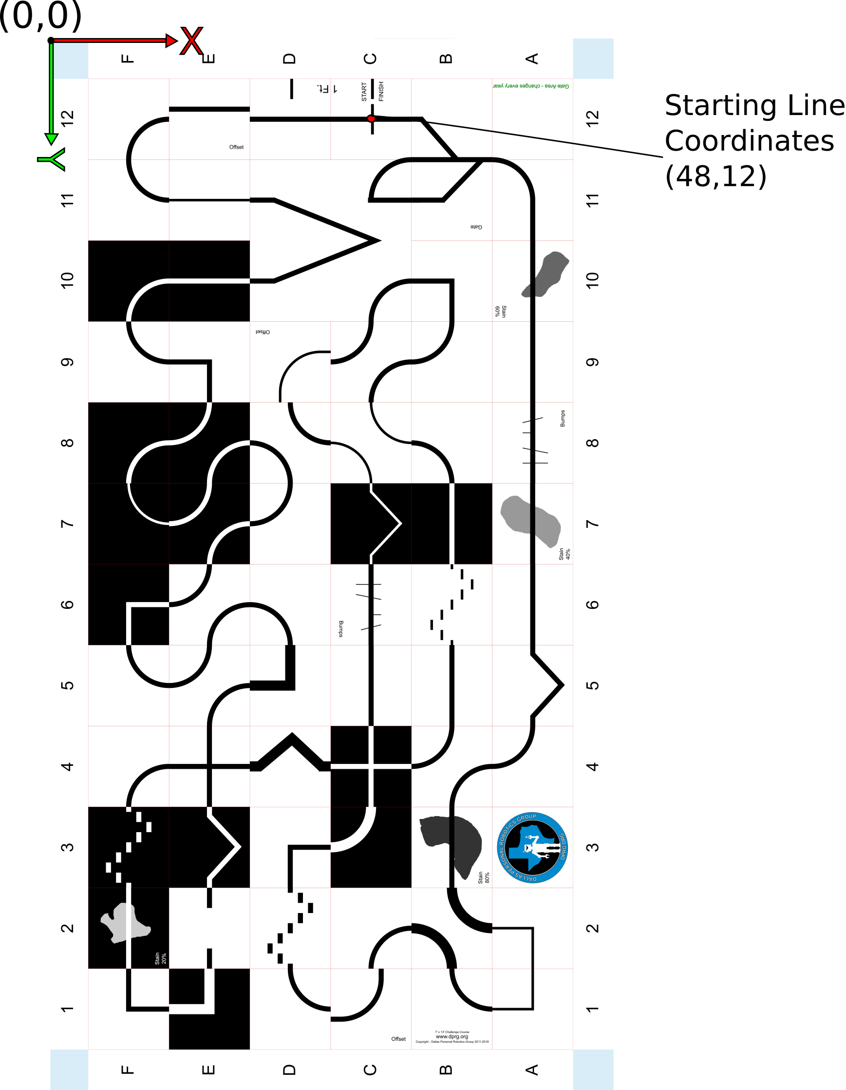

Robot Heading

Robot default heading 0 degrees.
Positive turnRate will turn robot in direction of arc (right turn) with increasing
heading, while negative turnRate will turn robot the other direction (left turn)
with decreasing heading.

Heading values are confined to the interval 0..359.99,
e.g. decreasing heading crossing 0 (and going negative) has 360 added to its values. Likewise, increasing heading exceeding 360 (359.99) will have 360 subtracted
from its value.

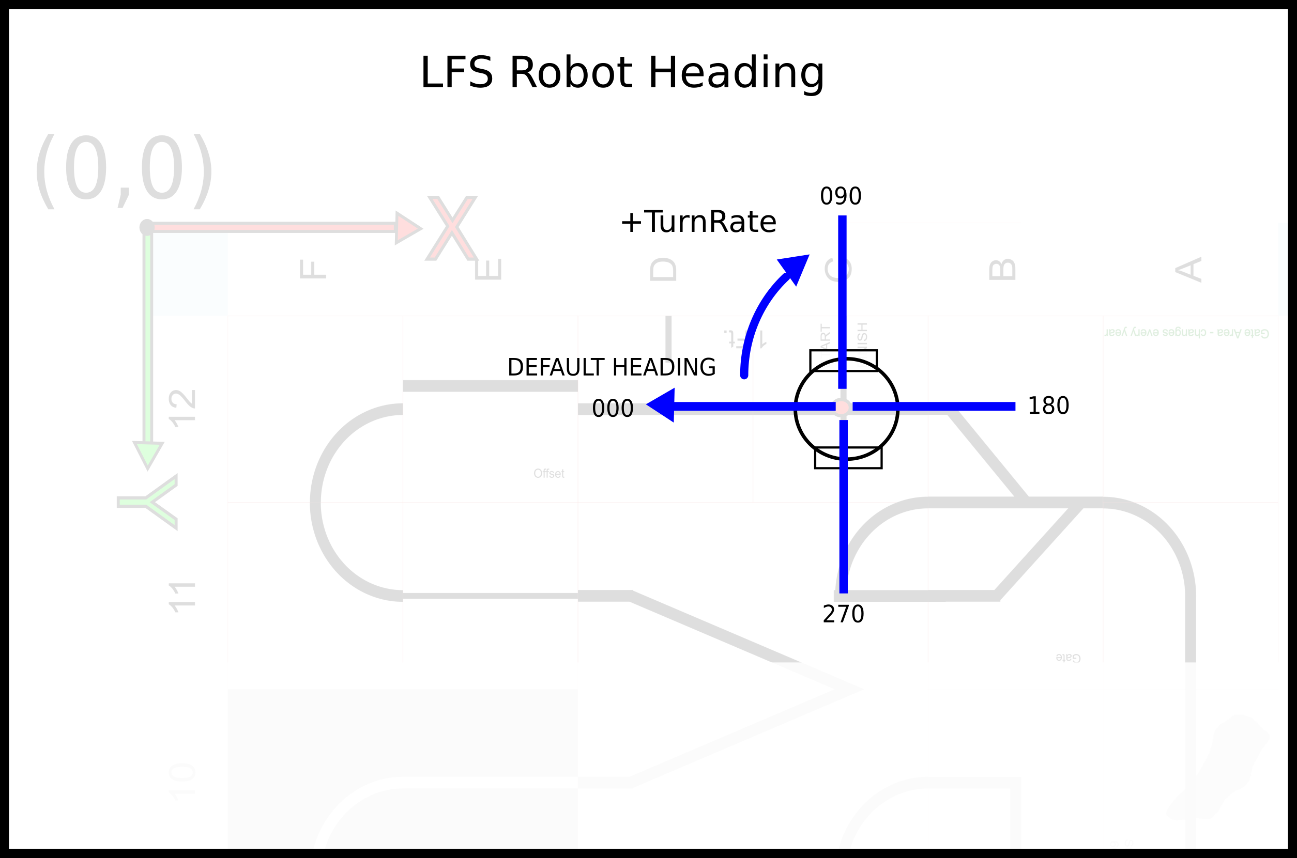

Robot Coordinates / Robot View

Robot origin (0,0) is midpoint between wheels, center of screen in robot view.
Robot position in world is such that robot origin is placed at current world (x,y) location.

The screen image below shows robot overhead view (robot is invisible).
Location is 4 inches forward of position shown in LFS World Coordinates diagram.
Note: In a contest you would start behind the “start/end” line – not in front of it.

Sensors are located in robot coordinates, e.g. , bar sensor location is at (2,0)
Left spot sensors is located at (1,-1.5), center at (1,0) and right at (1.0,1.5)
in inches.
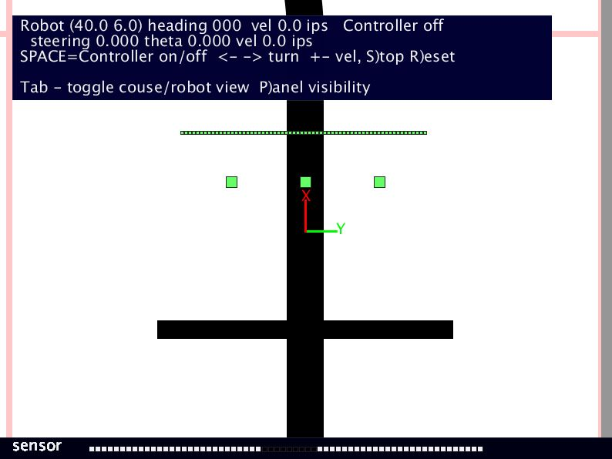
Note: Sensor data shown at the bottom of this screen may not appear or appear differently. Current goal is to create a viewport overlay with sensor data. -

Notes

